Honors Pre-Calc/Trig Unit 6 Assessment
Learning Goal 1 Graphing
Name _______________________________

Level 2/Basic
1. Sketch each graph:
a) y=x² b) y=x³ c) y=|x| d) 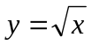 e) 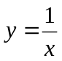

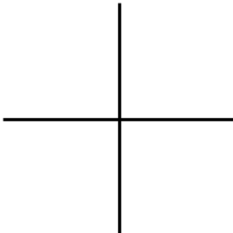

2. Describe the transformations used to obtain each function from y=x².

a) y = (x-3)² ________________________________ b) y=x²+7 ________________________________

c) y = -x² ________________________________ d) y=5x² ________________________________

3. Sketch the graphs:
a) y=|x|+3 b) y= 4|x| c) 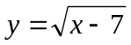 d) 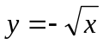

Level 3/Proficient
1. Sketch the graphs:
a) y=2|x+1|-3 b) 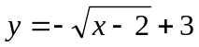 c) y=-(x-3)²-1 b) 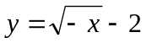

2. Write the equation of a square root function shown.

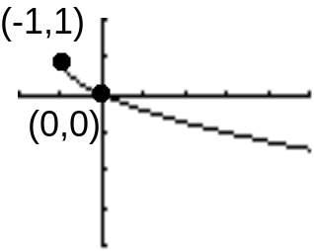 2. __________________________

3. Write the equation of an absolute value function that includes
lines of slope ±3, and a maximal function value of 7 that occurs
when the x-value is 3. 3. __________________________

Level 4/Advanced
1. Shade the area of the region satisfying y ≥|x-1|-3 and y ≤ -2|x-4|+6.

1. __________________________

2. Shade the area of the region bounded by |x|+|y|≤4.

2. __________________________

Honors Pre-Calc/Trig Unit 6 Assessment---Learning Goal 2 Combining Functions

Level 2/Basic
1. Find the domain of f(x)= 3x²+7x+5 1. __________________________

2. Find the domain of 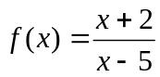 2. __________________________

3. Find the domain of 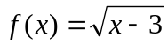 3. __________________________

4. f(x) = 3x+1 and g(x)= 2x+4 find (f+g)(x) 4. __________________________

5. f(x) = 3x+1 and g(x)= 2x+4 find (f-g)(x) 5. __________________________

6. f(x) = 3x+1 and g(x)= 2x+4 find (fg)(x) 6. __________________________

7. f(x) = 3x+1 and g(x)= 2x+4 find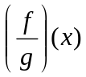 7. __________________________

8. f(x) = 3x+1 and g(x)= 2x+4 find f(g(x)) 8. __________________________

9. The function values of two functions are given in the following tables:
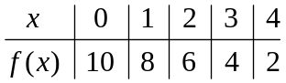 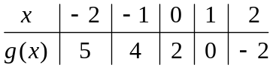 Find the following:

a) f(3) ________ b) g⁻¹(2) __________

10. The graph of f(x) and g(x) are shown below
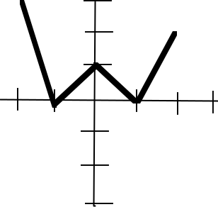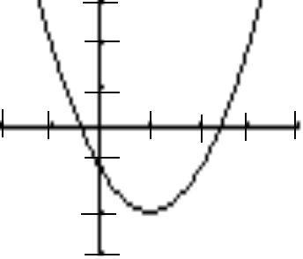

a) f(0) ________ b) g (1) __________

Level 3/Proficient
1. f(x) = x²+3x+2 and g(x)= 2x+1 find f(g(x)) 1. __________________________

2. f(x) = x²+3x+2 and g(x)= 2x+1 find g(f(x)) 2. __________________________

3. g(x)= 2x+1 find g(g(x)) 3. __________________________

4a. Find the inverse of f(x)=3x+2. 4a) __________________________

Use composition of functions to show that the f(x) and the inverse found in part (a) are inverses of each other.

4b) __________________________

5. Find the inverse of y=(x+2)²-3 5. __________________________

6. Find two function whose composition is 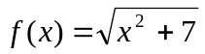 6. __________________________

7. Find two function whose composition is y=|8x+2|-3 7. __________________________

8. The function values of two functions are given in the following tables:

a) f(g(0)) __________ b) g⁻¹(f ⁻¹(2)) ____________

9. The graph of f(x) and g(x) are shown below

a) g(f(-2)) _______ b) Find x when g(x)=-1 __________

Level 4/Advanced
1. As a salesperson, you currently receive a monthly salary of $2000, plus a 7% commission on your sales. You are offered a new job that pays $2300 a month, but only 5% commission on sales. Write and solve an equation that proves how much you will have to sell each month to justify taking the new job.

1. ________________________

2. You are in a boat 2 miles from the nearest point on the coast. You are to travel to a point Q, 3 miles down the coast and 1 mile inland (see picture below). You can row at 2 miles per hour and you can walk at 4 miles per hour.

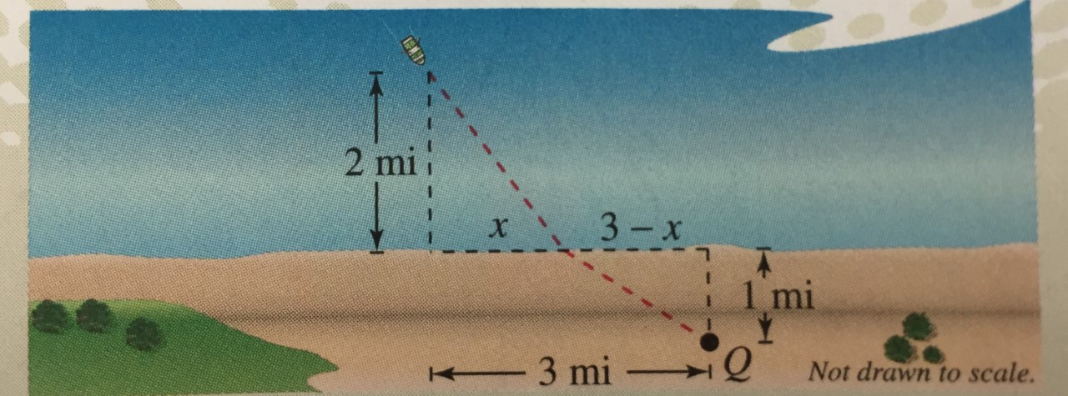

- Determine the total time T of the trip as a function of x
- State the domain of the function.
- Find the value of x that minimizes the time, T, to reach point Q.
- __________________________

b. __________________________

c. __________________________

